Unit 3 - Equations in Two Variables
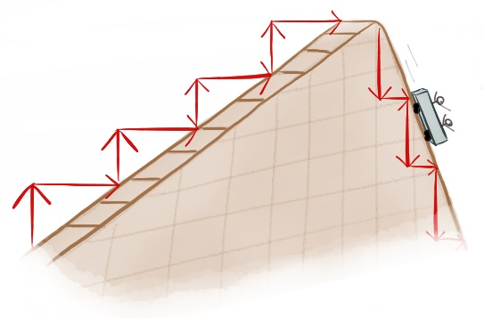
Lesson 1: Finding Slope Graphically.
Objective: Today we will find the slope of a line given the graph.
Standard: 8.EE.6

The steepness of a line is called _______!

Circle the line with the biggest slope…

Slope is identified by the variable $m$.
Slope Formula: $m=$

** Slope is the ratio of a line’s ________ change to its __________ change. That’s what we mean by “rise over run”!
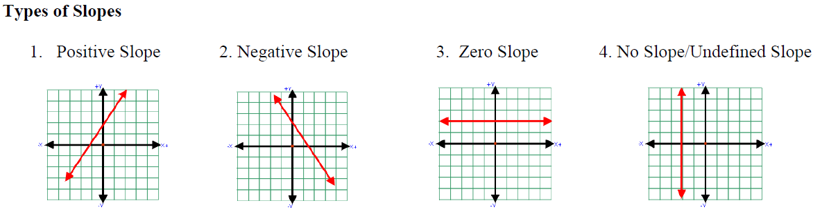

Example:
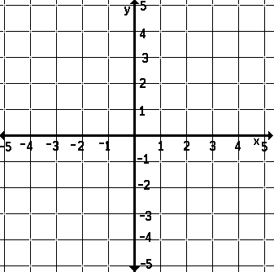
1) Start towards the left of the graph.
2) Find the rise from one point to the next
Up: ________
Down: ________
3) Find the run from one point to the next
Right: ________

Try It! Find the slope of the following lines!

m = m = m = m =

Lesson 2: Finding slope algebraically.
Objective: Today we will find the slope of a line algebraically.
Standard: 8.EE.6
Sometimes we are not given a picture, but instead we are given points on the line. When this is the case, we must implement another definition of slope:
$m=$ In other words, slope is

How to find the slope of a line when given points on the line:

1) Subtract one y-value from another y-value!
(It helps to label the points!)
2) Subtract one x-value from another x-value!
(It helps to label the points!)
Subtract from ordered pairs in the same order!

Examples:
$$x$$ | $$y$$
1 | 3
2 | 6
3 | 9
4 | 12
$\left(-2, 3\right) and (1, 7)$

Lesson 3: Comparing slopes.
Objective: Today we will compare slopes in different forms.
Standard: 8.EE.5
Finding slope from an equation:
- The equation must be in the form $______________$
This is called ________________________.
- The value ____, or the coefficient of x, is the slope of the equation.
We can compare the slope from a _______, from an __________, and from a _________________________.

Example:
Below are representations of Jesse, Troy, and Lucy’s usage of gas. Who has the highest miles per gallon?
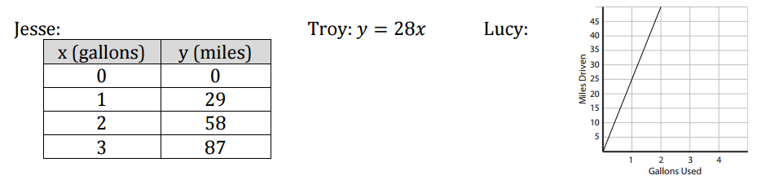

Lesson 4: Understanding Slope and Y-Intercept.
Objective: Today we will identify the y-intercept and slope from the graph of a linear equation.
Standard: 8.F.4
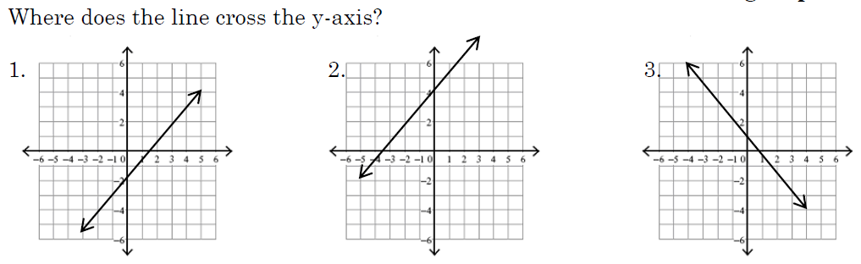

The point where the line crosses the y-axis is called the ________________
How do we find the slope of a line graphically? ________________________________
What is the slope formula? _________________________________
What letter do we use to represent slope? _____________________________

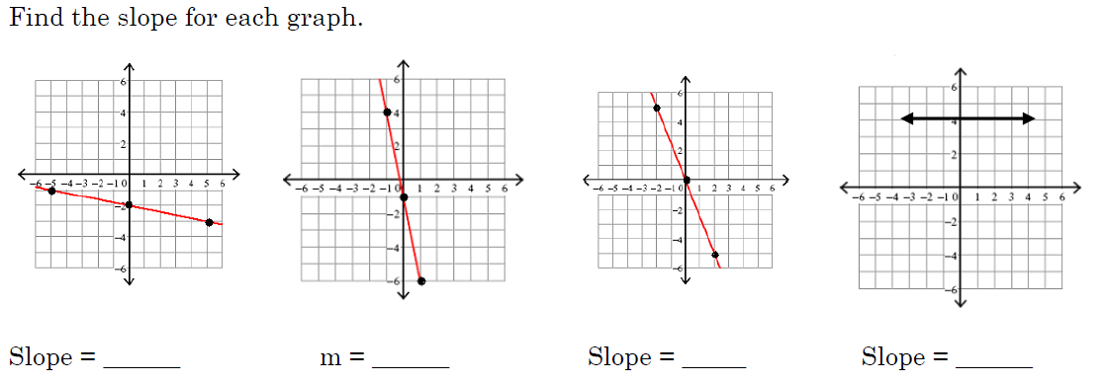

Lesson 5: Writing the equation of a line in slope-intercept form.
Objective: Today we will write the equation of a line in slope-intercept form.
Standard: 8.F.4
To write the equation of a line we need two pieces of information
_______ and ____________
The ____________________ is the point where the line crosses the __________.
The slope-intercept form of a line is $_________________$
The $m$ represents the ___________
The $b$ represents the ______________
- Find the slope or y-intercept from each equation.
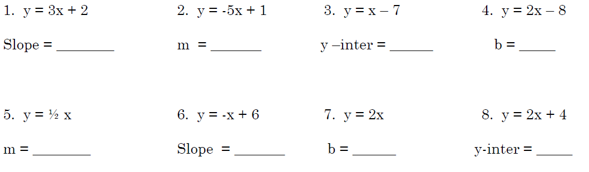

- Write the equation for each line given.
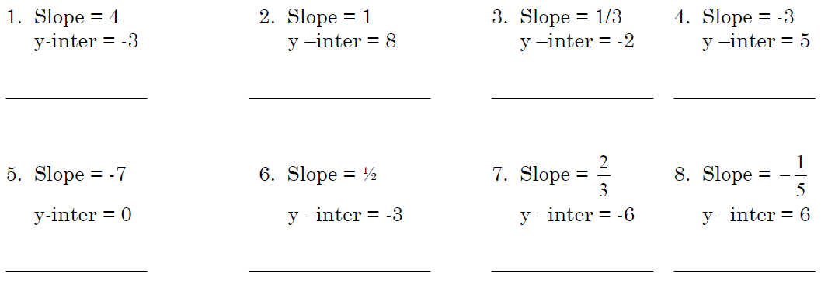

- Write the equation of each line from the graph.
What two pieces of information do we need in order to write the equation of a line?
________________________________________
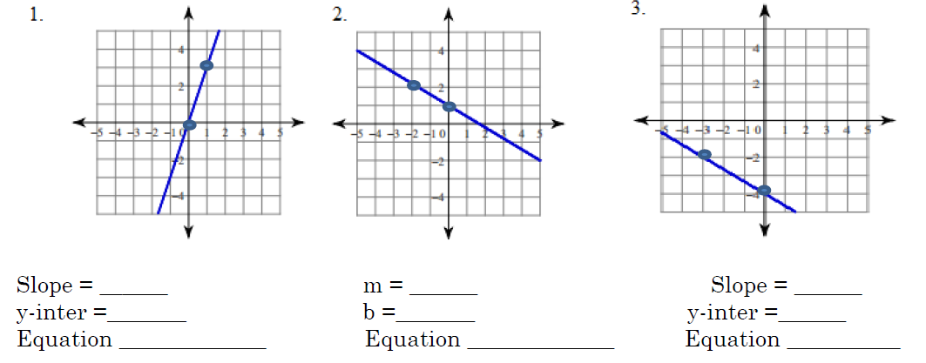

Lesson 6: Writing the equation of a line in slope-intercept form given the slope and a point.
Objective: Today we will write the equation of a line in slope-intercept form given the slope and a point.
Standard: 8.F.4
When Given the Slope and a Point:
- Substitute the slope for $m$ in the ____________________ equation.
- Substitute the point for $______________$ into the equation.
- Use _____________________ to solve for $b$.

Example:
Write the equation of the line with a slope of $-2$ that passes through
the point (3, -5).

Write the equation of the line with a slope of $\frac{2}{3}$ that passes through
the point (6, 2).

Lesson 7: Writing the equation of a line in slope-intercept form given two points.
Objective: Today we will write the equation of a line in slope-intercept form given two points.
Standard: 8.F.4
When Given Two Points:
What information are we missing in order to write the equation of a line?
______________________________
How do we find the slope given two points? ___________________
Steps:
- Find the slope
- Use one point and the slope to find the $______$.
- Write the final equation.
Example:
Write the equation of the line in slope-intercept form that passes through the points $(3, 2)$ and $(5, 4)$.

Write the equation of the line in slope-intercept form that passes through the points $(3, -6)$ and $(-1, 2)$.

Lesson 8: Solving equations for y.
Objective: Today we will rewrite linear equations in slope-intercept form.
Standard: 8.F.3

To be able to identify the slope and y-intercept of a line, the equation needs to be in the form $_________________$.

Lesson 9: Graph a line from a table.
Objective: Today we will graph a linear equation from a table.
Standard: 8.F.3
Steps:
- Pick three _____________
- Substitute x-values into the equation to find _____________
- Use the ordered pairs to plot and make a line
- Extend the line, put arrows on both ends, and label the line with the equation
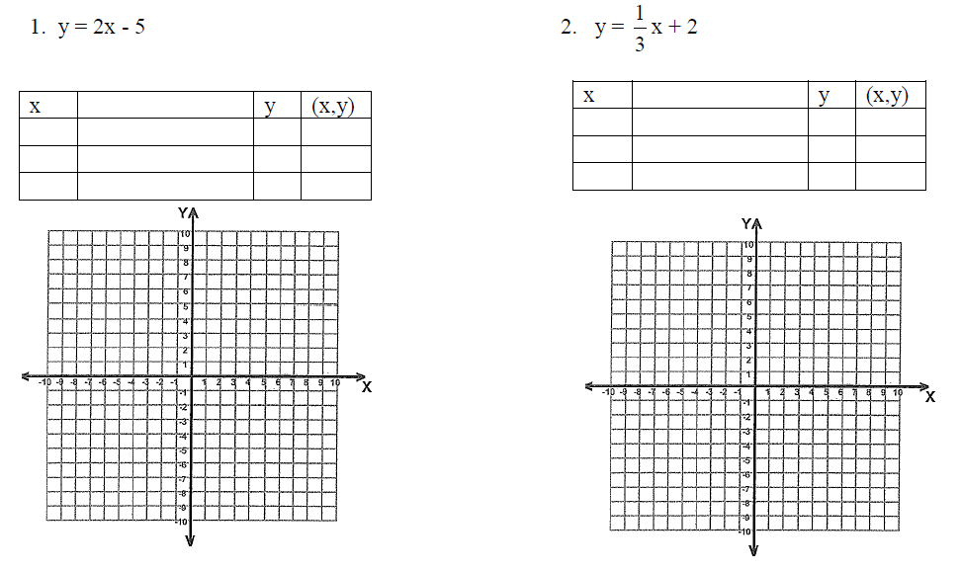

Lesson 10: Graph lines in slope-intercept form.
Objective: Today we will use the slope-intercept form of a line to graph the line.
Standard: 8.F.3
Graphing Using Slope-Intercept:
- Identify the _______ and ____________ from the equation.
- Plot the _____________.
- Use the slope to get additional points (at least 3)
- Connect and extend
- Label

Examples:
Graph the lines:
$y=x+1$ $y=-\frac{1}{4}x-1$
$m=____$ $b=____$ $m=____$ $b=____$

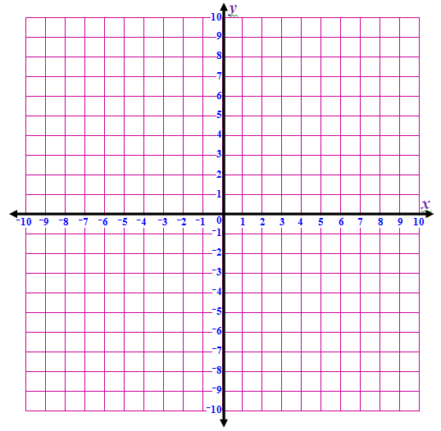

Lesson 11: Graphing a linear equation when you are not given slope-intercept form.
Objective: Today we will convert a linear equation into slope-intercept form to graph the line.
Standard: 8.F.3
Sometimes you are given an equation that is not in slope intercept form:
$$___________________________$$
Your line MUST be in slope-intercept form for you to be able to graph the line.
- Write in slope-intercept form ($y=mx+b$)
- Identify the _______ and _____________ from the equation.
- Plot the _____________.
- Use the slope to get additional points (at least 3)
- Connect and extend
- Label

Example:
Graph the linear equation.
$$3x-4y=12$$

Slope-Intercept Form
_______________
$m=____$ $b=____$

