Name_____________________________ Date_________

Homework #1 - Due Friday 9/14

Directions: Write the following expressions in exponential form.

- 2.

Directions: Write the following expressions in expanded form.
3. 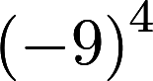 4.

5. Interstate 70 stretches almost miles across the United States. About how many miles long is
Interstate 70?

Directions: Evaluate each expression using a calculator. Show your substitution!

6. When and 7. When 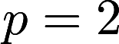 and
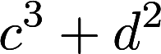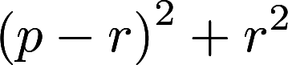

8. When and 9. When and
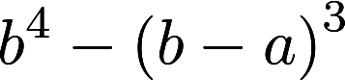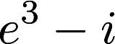

10. When and

Directions: Simplify.

11. 12. 13.

14. 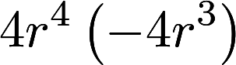 15. 