Name_____________________________ Date_________

Homework #10 - Due Friday 12/7

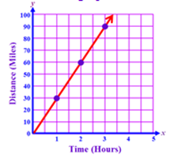
- The distance a rabbit can run is given by the equation . The distance covered by a grizzly bear is shown on the graph.
Which animal is faster?

Directions: Identify the slope and y-intercept.
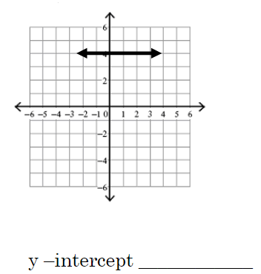
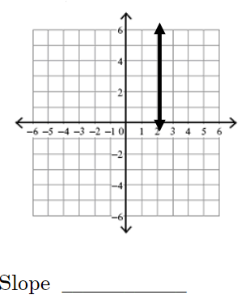
- 3)

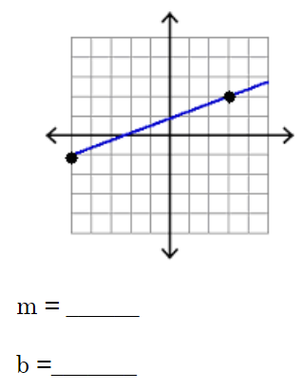
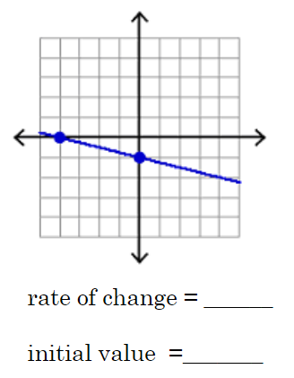
- 5)

6) Given , what is the slope of the line? ______

7) If the slope of the line is and the y-intercept is 6 what is the equation of the line? ________

8) Write the equation of the line given 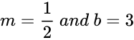. ________

9) Write the equation of the line given . __________

10) Write the equation of the line that passes through the point (-7, 10) and has a slope of -4.

11) Write the equation of the line that has a slope of and passes through the point (6, 2).

12) Write the equation of the line that passes through the point (-1, -4)with a slope of 1.

13) Write the equation of the line that passes through the point (6, 2) and has a slope of 

