Name_____________________________ Date_________

Homework #11 - Due Friday 12/14

Directions: Write the equation of the line in slope-intercept form.

- Write the equation of a line that passes through the points (0, 3) and (-4, -1).

- Write the equation of a line that passes through the points (-4, 2) and (0, -5).

- Write the equation of a line that passes through the points (-4, -2) and (-3, 5).

- Write the equation of a line that passes through the points (0, 2) and (1, -3).

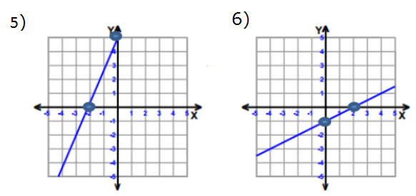
m = ______ m = _______

b = ______ b = ______

Equation: ____________ Equation: ____________

7) Graph the line given the table:
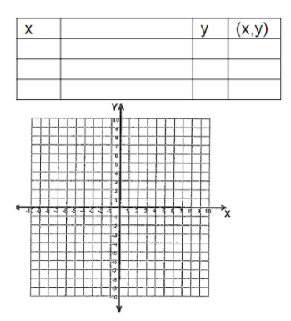

Graph each line given the slope and y-intercept.
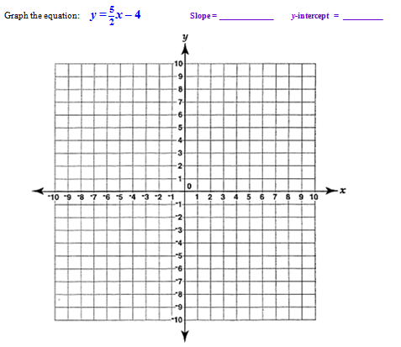
8.

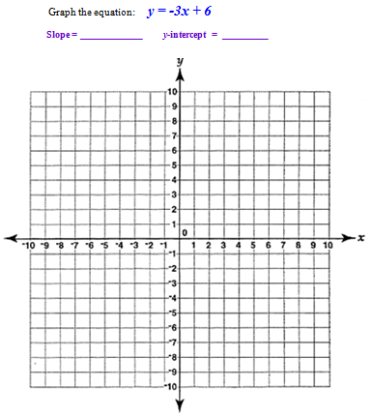

9.

