Name_____________________________ Date_________

Homework #5 - Due Friday 10/19

Directions 1-5: Solve each equation. Show all work. (2 ea)

- 2)

3) 4)

5) 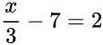

Directions 6-11: Write an equation for each problem. Then solve the equation. Show all work. (2 ea)

6) Seven more than three times a number is 16.

7) The product of a number and 4 plus 2 is 14.

8) Over the weekend, Koko spent 2 hours on an assignment, and she spent equal amounts of time studying for 4 exams for a total of 16 hours. How much time did she spend studying for each exam?

9) At the market, Meyer buys a bunch of bananas for $0.65 per pound and a frozen pizza for $4.99. The total for his purchase was $6.94, without tax. How many pounds of bananas did Meyer buy?

10) Laura is making a patio in her backyard using paving stones. She buys 44 paving stones and a flowerpot worth $7 for a total of $73. How much did each paving stone cost?

11) While at the music store, Drew bought 5 CDs, all at the same price. The tax on his purchase was $6, and the total was $61. What was the price of each CD?

Directions 12-15: Solve each equation. Show all work. (3 ea)

12) 13)

14) 15)

Directions 16-18: Write and solve an equation to find the value of the variable. Use the value of the variable to solve for the missing side length. (4 ea)

16) In the figure ABCD below, the total length of the sides equals 175 feet.
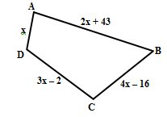
- Find the value of x.

b) Find the length of side BC.

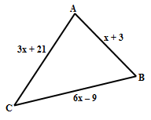
17) In the triangle ABC below, the total length of the sides equals 255 feet.

- Find the value of x.

b) Find the measure of side AB.

18) In the triangle ABC below, the total length of the sides equals 117 inches.

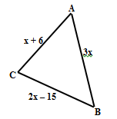
- Write and solve an equation to find x.

b) Find the measure of side AC.

