Unit 7 - Angles
Lesson 1: Complementary Angles.
Objective: Today we will find missing angle measurements involving complementary angles.
Standard: 8.G. 5
Complementary Angles
________________ angles add up to equal $90°$.
Complementary angles do not have to be __________ (next to each other) for them to be complementary.
Try These:
- Complementary angles are two angles whose sum is _______
- Complementary angles form what type of angle? _______
- What is the complement of a 40 degree angle? _______
- What is the complement of a 4 degree angle? _______
- What is the complement of $30°$? _______
- What is the complement of $x°$? _______
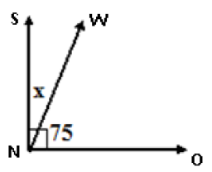
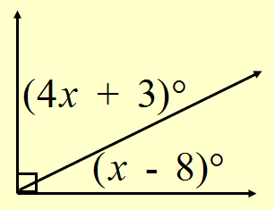
Solve for $x$ by setting up an equation

Lesson 2: Supplementary Angles.
Objective: Today we will find missing angle measurements involving supplementary angles.
Standard: 8.G.5
Supplementary Angles
________________ angles add up to equal $180°$.
An angle that equals $180°$ is called a ____________________.
Supplementary angles do not have to be adjacent for them to be supplementary.
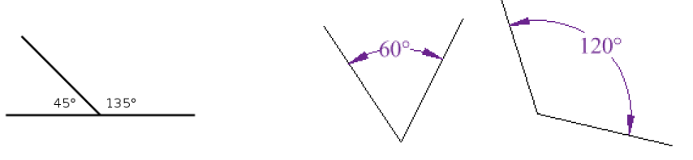
Try These:
- Supplementary angles are two angles whose sum is _______
- Supplementary angles form what type of angle? _______
- What is the supplement of a 40 degree angle? _______
- What is the supplement of a 4 degree angle? _______
- What is the supplement of $30°$? _______
- What is the supplement of $x°$? _______
Find the missing angles by setting up an equation.
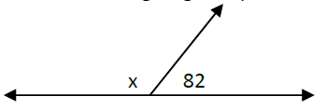
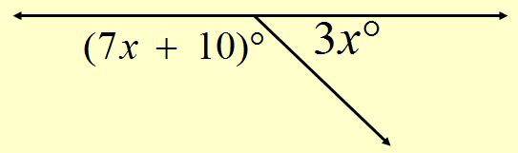

Lesson 3: Vertical Angles.
Objective: Today we will find missing angle measurements involving vertical angles.
Standard: 8.G.5
Vertical Angles
__________________ are opposite angle pairs formed by two intersecting lines.
Vertical angles are ___________.
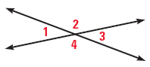
$____________________$ are vertical angles
$____________________$ are vertical angles

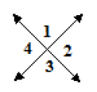
Use the picture to the right:
- Name an angle congruent to angle 1 _______
- Name an angle supplementary to angle 1 _______
- If angle 1 = $70°$, then: $<2=_____$, $<3=_____$, $<4=____$_
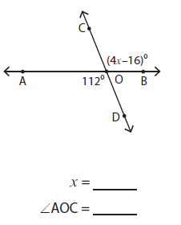
Example:
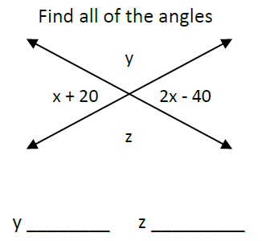

Lesson 4: Angle Relationships
Objective: Today we will find missing angle measurements involving parallel lines cut by a transversal.
Standard: 8.G.5
________________ are lines that do not
intersect.
A ______________ is a line that crosses two
or more parallel lines.
1
4
2
6
5
7
8
3

- Angles that are in the same position on both parallel lines are congruent. (______________________)
- Angles that share a side (next to each other) are supplementary.
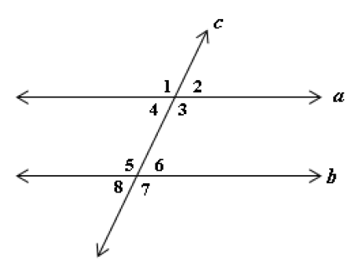
- Angles that are across from each other are vertical angles.
Use the diagram to answer the questions:
- Lines $a$ and $b$ are ___________
- Line $c$ is called the ____________
- Name a pair of vertical angles _____ & _____
- Name a pair of corresponding angles
_____ & _____
- Name a pair of supplementary angles
_____ & _____
- Name a pair of congruent angles ____ & _____
- True or False: $<1≅<5$? _____
- True or False: $<4≅<5$? _____
- True or False: $<1≅<6$? _____
- True or False: $<4≅<6$? _____

- If $<1=60°$, then:
$<2=$_____
$<3=$_____
$<4=$_____
$<5=$_____
$<6=$_____
$<7=$_____
$<8=$_____

- If $<6=100°$, then:
$<1=$_____
$<2=$_____
$<3=$_____
$<4=$_____
$<5=$_____
$<7=$_____
$<8=$_____

Lesson 5: Angle Relationships
Objective: Today we will find missing angle measurements involving parallel lines cut by a transversal.
Standard: 8.G.5
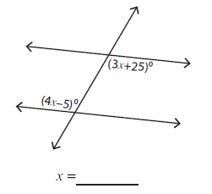
- Find the value of $x$.

What are the measurements of the two angles?
__________ and _________

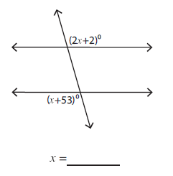
- Find the value of $x$

What are the measurements of the two angles?
________ and ________
Lesson 6: Interior Angles of a Triangle
Objective: Today we will find the measure of an interior angle of a triangle.
Standard: 8.G. 5
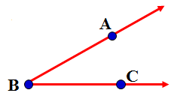
Naming Angles:
We name angles using 3 points.
The vertex must be the middle letter.
The angle can be named:
- $Type equation here.$
- $Type equation here.$

Interior Angles of a Triangle
- A __________ is a three sided polygon.
- An angle that lies inside a triangle is called an _____________.
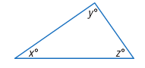
The sum of the measures of the
interior angles of a triangle is $180°$.
$x+y+z=180°$

Example:
Find the value of $x$ in the diagram.
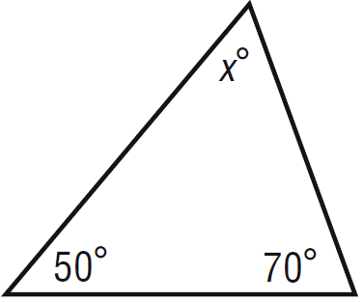

Lesson 7: Exterior Angles of a Triangle
Objective: Today we will find the measure of an exterior angle of a triangle.
Standard: 8.G. 5
Exterior Angles of a Triangle
___________________ are interior angles that are not ________ to the exterior angle.
The ______________________ states that the exterior angle of a triangle is equal to the sum of its two remote interior angles.

Examples:
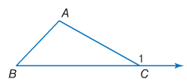
- If $<A=91°$ and $<B=35°$ find $<1$

- Suppose $<4=135°$. Find the measure of $<2$.
