Unit 2 - Solving Equations
Lesson 1: Solving Two-Step Equations.
Objective: Today we will solve two-step equations with rational coefficients.
Standard: 8.EE.7b
Two-Step Equations
To solve two step equations you will need to use the properties of equality.
This can also be referred to as using ________________________.
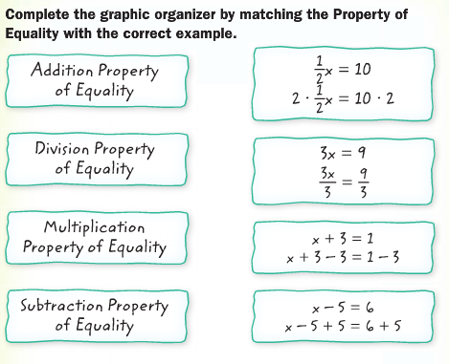
A __________ equation contains two operations. This means that there will be ____ steps needed to solve the equation.
Examples: Solve the following equations.
$2x+8=20$ $25=\frac{1}{4}n-3$ $6-3x=21$

Lesson 2: Write and Solve Two-Step Equations.
Objective: Today we will write and solve two-step equations that represent real-world situations.
Standard: 8.EE.7b
Writing Two-Step Equations
Follow these three steps to write a two-step equation.
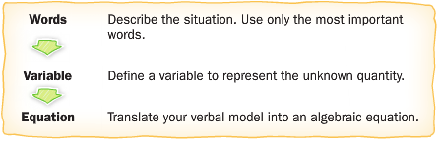
Examples:
- Translate the sentence into an equation. Then solve.
Eight less than three times a number is $-23$.
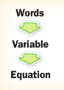
- You buy 3 books that each cost the same amount and a magazine, all for $55.99. You know that the magazine costs $1.99. How much does each book cost?
Lesson 3: Solving Equations by Combining Like Terms.
Objective: Today we will solve multi-step equations that involve combining like terms.
Standard: 8.EE.7b
Combining Like Terms
When you are combining like terms, you can only combine terms that have the same ___________ with the same ___________.
$a^{2}-4a+5a$ $3y+4x^{2}-3y+5y$ $3h+14g-5h+5g$

You will need to combine like terms before using inverse operations to solve an equation.
Examples:
- $2x+5x=28$

- $2t+8+\frac{1}{2}t-t=11$

Lesson 4: Combining Like Terms for Perimeter.
Objective: Today we will solve perimeter problems that involve combining like terms.
Standard: 8.EE.7b
Combining Like Terms – Perimeter
To find the perimeter of a figure you need to find the _____ of the sides.
You will then need to combine _____________ and use ___________________ to solve the equation.

Example:
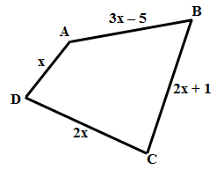
- In the figure ABCD below, the total length of the sides equals 92 inches. Find the value of $x$.

Lesson 5: Solving Equations by Using the Distributive Property.
Objective: Today we will solve multi-step equations that involve the Distributive Property.
Standard: 8.EE.7b
The Distributive Property
When you are using the Distributive Property, you must make sure that you multiply the factor outside the parentheses with all terms inside the parentheses.
$3(m-4)$ $-2(y+3)$

- Use the Distributive Property
- Combine any _____________
- Use _____________________
Examples:
- $2\left(x+6\right)=20$ 2. $3\left(2p+1\right)-13=44$

Less on 6: Solving Equations with Variables on Each Side.
Objective: Today we will solve equations with variables on each side.
Standard: 8.EE.7b
Variables on Each Side
- Use the _________________________
- Combine ______________
- Use ____________________to bring all variables to one side and all constants on the other side
- Solve the equation
Examples:
- Solve $8+4d=5d$. 2. Solve $6n-1=4n-5$.

- $2\left(x-4\right)=5x+1+3x$

Lesson 7: Solving Perimeter Problems by Solving Equations with Variables on Both Sides of the Equation.
Objective: Today we will solve perimeter problems involving variables on both sides of the equal sign.
Standard: 8.EE.7b
Perimeter
Perimeter is the ____________________ of any shape.
Example:
Write an equation to find the value of x so that the pair of polygons has the same perimeter.
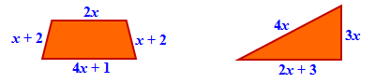

Lesson 8: Determine the Number of Solutions.
Objective: Today we will determine the number of solutions for a given equation.
Standard: 8.EE.7a
What does the word solution mean? ___________________________
When solving an equation there are THREE possible types of solutions:
______________ ______________ __________________

We can figure out how many solutions an equation has by solving,
and even without solving!
You can determine the number of solutions by simplifying the equation.
One Solution
Examples
$4x-2=10$ $3x-8=2x+1$ $6x-2x+9=45$
An equation has only one solution when: ______________________________________
___________________________________________________________________
No Solutions
Examples
$5x-9=5x+2$ $2\left(x+6\right)=2x-8$ $3\left(x-8\right)+x=2x+1+2x$
An equation has no solutions when: _________________________________________
___________________________________________________________________
Infinite Solutions
Examples
$7x-4=7x-4$ $3x-9+2=x+2x-7$ $5\left(8x+1\right)=60x+5-20x$
An equation has infinite solutions when:______________________________________
___________________________________________________________________
Lesson 9: Variables on Both Sides of the Equation with Distributive Property
Objective: Today we will solve multi-step equations with the variable on both sides of the equal sign involving the distributive property.
Standard: 8EE.7b
Multi-Step Equations – Distributive Property

Step 1: Use the ______________________.
Step 2: Use __________________to get the variable on one side and the constants on the other side.
Step 3: Solve the resulting _____________.

Examples:
Solve the equations.
$4n-40=7(-2n+2)$ $3\left(1-3x\right)=2(-4x+7)$

Lesson 10: Variables on Both Sides of the Equation with Combining Like Terms
Objective: Today we will solve multi-step equations with the variable on both sides of the equal sign involving combining like terms.
Standard: 8EE.7b
Multi-Step Equations – Combining Like Terms
Step 1: Combine all ______________.
Step 2: Use ______________________ to get the variable on one side and the constants on the other side.
Step 3: Solve the resulting ____________.

Examples:
Solve the equation.
$18x+x=5x-7$ $-14+6b+7-2b=1+5b$

Lesson 11: Variables on Both Sides of the Equation with Combining Like Terms and the Distributive Property
Objective: Today we will solve multi-step equations with the variable on both sides of the equal sign involving combining like terms and the distributive property.
Standard: 8EE.7b
Multi-Step Equations
Step 1: Use the ____________________________.
Step 2: Combine all ___________.
Step 3: Use _________________ to get the variable on one side and the constants on the other side.
Step 4: Solve the resulting ________________.
Examples:
$2\left(x-4\right)=5x+1+3x$ $-8n+4\left(1+5n\right)=-6n-14$

Lesson 12: Solve Fractional Equations.
Objective: Today we will solve fractional equations using a proportion.
Standard: 8.EE.7b
Fractional Equations
Step 1: __________________.
Step 2: Solve the resulting equation.
Examples
Solve the equation.
- $\frac{10}{8}=\frac{n}{10}$

- $\frac{5}{6}=\frac{7n+9}{9}$

Lesson 13: Solve Fractional Equations.
Objective: Today we will solve fractional equations by finding a common denominator.
Standard: 8.EE.7b
Fractional Equations
Step 1: Identify the _______________________.
Step 2: ________ every term by the common denominator.
Step 3: ________ each term to have an equation with no denominators.
Step 4: Solve the resulting equation.
Examples:
Solve the equation.
- $\frac{x}{3}-\frac{2x}{5}=\frac{-7}{15}$ 2. $\frac{x+3}{5}-\frac{3x}{10}=7$

Lesson 14: Solving Real-World Problems Involving Equations with Variables on Each Side.
Objective: Today we will use equations with variables on each side to solve real-world problems.
Standard: 8.EE.7b
Word Problems
Follow these three steps to write an equation for a word problem:
Example:
- Green’s Gym charges a one-time fee of $50 plus $30 per session for a personal trainer. A new fitness center charges a yearly fee of $250 plus $10 for each session with a trainer. For how many sessions is the cost of the two plans the same?

