Unit 5 - Functions
Lesson 1: Writing a Function Rule.
Objective: Today we will write the rule for a given function.
Standard: 8.F.1, 8.F.3
Vocabulary
- _______ values – X-values of an ordered pair
- _________ Values – Y-values of an ordered pair
- Relation – A set of ordered pairs
- Function – A relation in which there are no repeating x-values
- Function Rule - $y=mx+b$

Making Function Tables
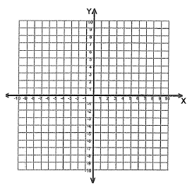
To find the output values of a function, substitute the input values for the variable in the function rule.
$$y=2x+1$$
Input | Function Rule | Output | Ordered Pair
$$x$$ | $$2x+1$$ | $$y$$ | $$(x, y)$$
$$0$$
$$1$$
$$2$$

Finding Function Rules
This year, the only function rules you will write will be linear functions. To write a function rule, then, is to write a linear equation!
Input $(x)$ | Output $(y)$
$$1$$ | $$2$$
$$2$$ | $$5$$
$$3$$ | $$8$$
What is the slope? __________________
What is the y-intercept? __________________
Write the equation for the line (function rule) ______________

Lesson 2: Determining if a relation is a function.
Objective: Today we will determine if a relation is a function.
Standard: 8.F.1, 8.F.3
Vocabulary
- The ___________ is the set of x-values.
- The _______ is the set of y-values.

Given the relation: $\{\left(1, 2\right), \left(2, 4\right), \left(3, 5\right), \left(2, 6\right), \left(1, -3\right)\}$
What is the domain:_________________
What is the range:__________________
Complete the following table and graph the function:
$$x$$ | $$y$$

Is this relation a function?
How do you know?

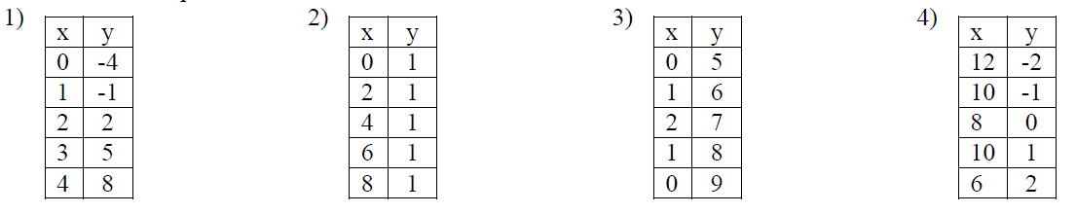
Which relation represents a function?

Which relation diagram represents a function?
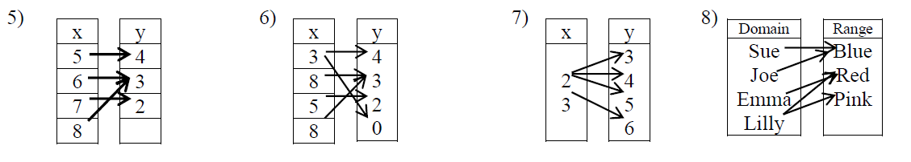

Using the Vertical Line Test
Which of the following graphs are functions?
How do you know?
A.  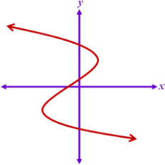 | B.  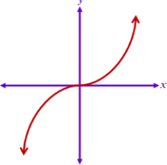 | C.  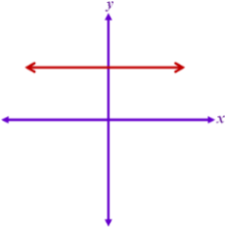 | D.  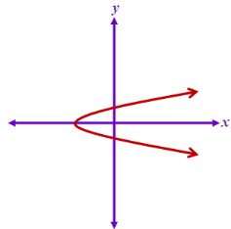

Lesson 3: Linear Vs. Nonlinear
Objective: Today we will identify if functions are linear or nonlinear.
Standard: 8.F.3
Linear Functions
- Have graphs that are _________ lines.
- The rate of change between any two points is __________.
- Variable terms can only have an exponent of ____.
Nonlinear Functions
- Have graphs that are ________________ lines.
- The rate of change between any two points is _________________.
- Variable terms will have exponents that are numbers other than _____.

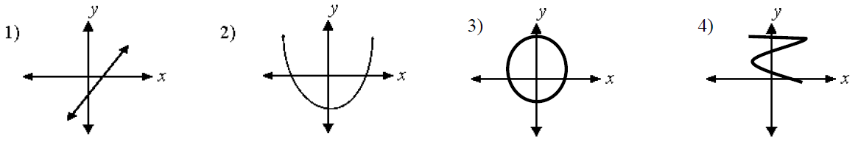
Tell whether the following are linear or nonlinear and justify your answer.

$$x$$ | $$y$$
0 | 5
2 | 3
4 | 0
6 | -4

$$x$$ | $$y$$
-5 | 15
-2 | 9
2 | 1
3 | -1

- $y=x^{2}$ d) $A=πr^{2}$ e) $3x-y=-12$

Lesson 4: Evaluating Functions
Objective: Today we will evaluate functions using function notation.
Standard: 8.F.1
Function Notation
$$f\left(x\right)=15x$$
This is read as: ____________________. This means that the equation represents a function and it uses the variable x.
- To evaluate a function for a given value, substitute the number for the variable.

Try It:
If $f\left(x\right)=2x+1$ find $f\left(-3\right)$

If $f\left(x\right)-\frac{1}{2}x-2$ find $f(12)$

Lesson 5: Proportional Linear Functions
Objective: Today we will identify proportional and non-proportional relationships.
Standard: 8.EE.5
Vocabulary
- Proportional Linear Functions – can be written in the form $__________$
** The y-intercept (b) is always 0 – which means the line will pass through the ________!
Example: $y=5x$
- Non-Proportional Linear Functions – Can be written in the form $_____________$
- Constant of Proportionality is $m$ or the ________ of the line. It represents the ___________.

Which equations represent a proportional relationship?

Compare the two graphs:
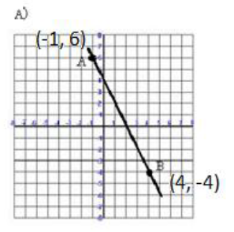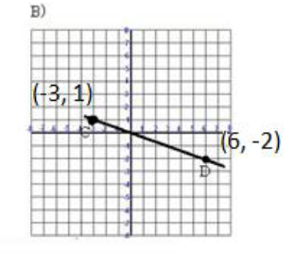
What is the slope for graph A? _____ What is the slope for graph B? _____
What is the equation of the line? __________ What is the equation of the line? ______
Which graph represents a proportional relationship? Justify your answer.
Lesson 6: Interpreting Graphs
Objective: Today we will interpret the rate of change and y-intercept for a graph.
Standard: 8.F.5
The _______ represents the rate of change of the function.
The _______________ represents the starting value of the function.

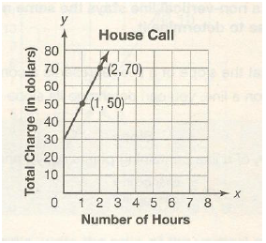
A locksmith charges a flat fee for each house call plus an hourly rate, as shown by the graph below.
What does the x-axis represent (in words)?
________________________________
What does the y-axis represent (in words)?
________________________________
What is the rate of change? __________
What does the rate of change represent (in
words)? __________________________
What is the y-intercept? ______________
What does the y-intercept represent (in words)?
____________________________________
What equation can we use to find how much a job will cost? _______________________
Find how much an 8 hour job will cost. ____________________

Lesson 7: Qualitative Graphs
Objective: Today we will interpret the meaning of qualitative graphs.
Standard: 8.F.5
Qualitative Graphs
When interpreting qualitative graphs you are telling a story of what is happening for the given situation.
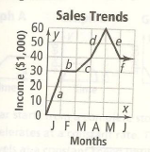
Use the graph at the right to answer the
following questions:
- Which sections of the graph are:
Increasing:
Decreasing:
Constant:

- What was the total change in income from the beginning of March until the end of April?

- What was the total change in income from the beginning of March until the end of May?

- Explain what could be happening during each section of the graph.

Lesson 8: Comparing Functions
Objective: Today we will compare rates of change and their graphs.
Standard: 8.F.2, 8.F.4
Comparing Functions
Comparing Rate of Change
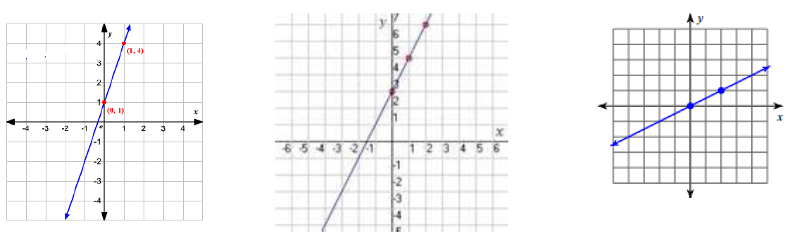
Which of the graphs is the steepest?

The greater rate of change has the higher _______________ of the slope of the line.
- Which equation has a greater rate of change?

- Which of the following has a greater rate of change?
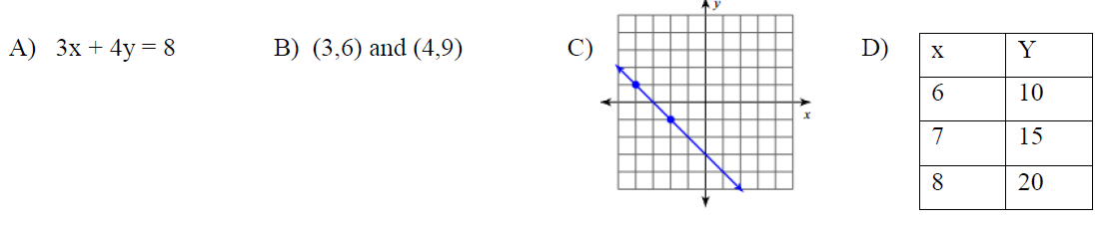

Comparing Two Linear Equations
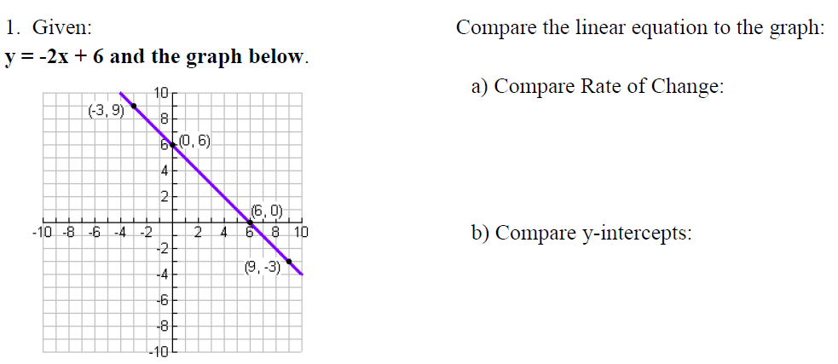

Lesson 9: Representing Functions
Objective: Today we will represent functions in different ways.
Standard: 8.F.4
Every function can be written in four ways:
- __________
- __________
- __________
- __________

Create a function rule to represent the situation.
- Emma is writing a term paper. She writes 3 pages per day. If $y$ represents the total pages and $x$ represents days, create a function rule for this scenario.

- A large pool contains 20,000 gallons of water. 5 gallons evaporate each day. $y$ is the gallons of water and $x$ is the days. Write an equation.

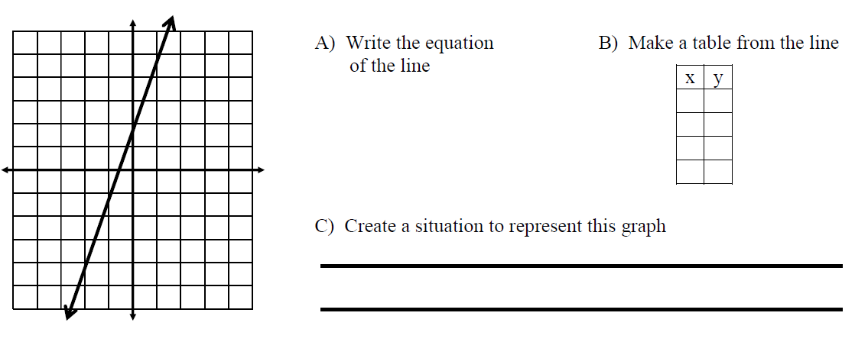
Creating a Situation

