Name_____________________________ Date_________

Homework #3 - Due Friday 9/28

1-10 Directions: Simplify.

- 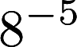 2. 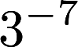 3. 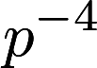

4. 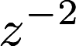 5. 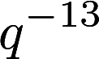 6.

7. 8. 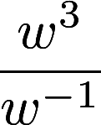 9. 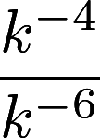

10. 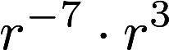

11-15 Directions: Write each number in scientific notation.

11. 12. 13.

14. 15.

16-20 Directions: Write each number in standard form.

16. 17. 18. 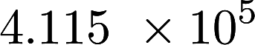

19. 20.

