Name_____________________________ Date_________

Homework #6 - Due Friday 10/26

Directions 1-5: Solve each equation. Show all work.

- 2)

3) In the figure ABCD below, the total length of the sides equals 294 yards.
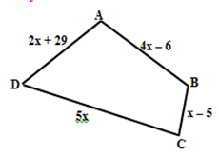
Find the value of x.

Find the measure of side CD.

4) 5) 6) 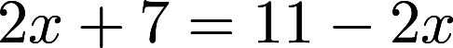

7) 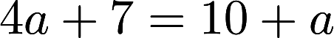 8) 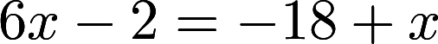 9) 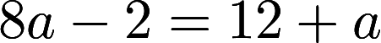

10) 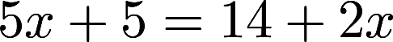

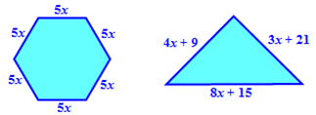
11) Write and solve an equation to find the value of x so that the polygons have the same perimeter.

12) Write and solve an equation to find the value of x so that the polygons have the same perimeter.
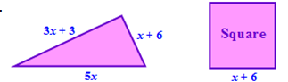

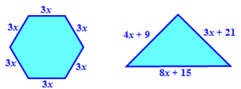
13) Write and solve an equation to find the value of x so that the polygons have the same perimeter.

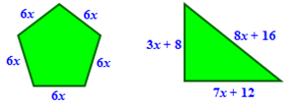
14) Write and solve an equation to find the value of x so that the polygons have the same perimeter.

15) Write and solve an equation to find the value of x so that the polygons have the same perimeter.
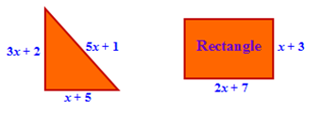

Directions 16-20: Identify if there is one solution, no solution, or infinite solutions.

16) 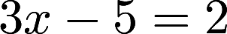 17) 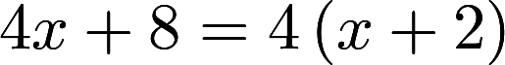

18) 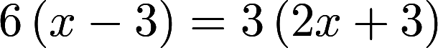 19) 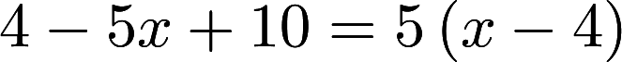

20)

