Name_____________________________ Date_________

Homework #9 - Due Friday 11/30

Directions#1-4: Find the slope of each line.
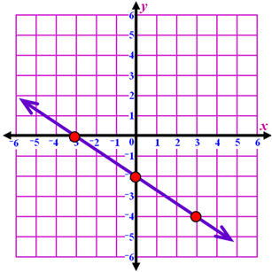
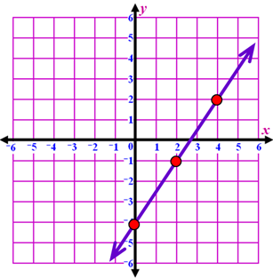
- 2)

m = __________ m = __________
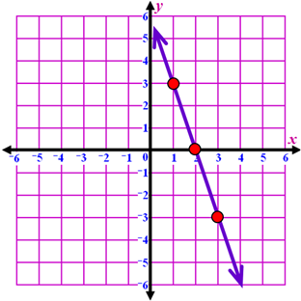
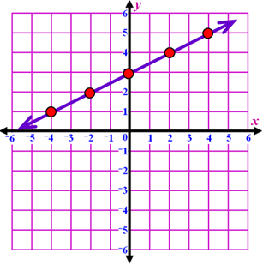
3) 4)

m = __________ m = __________

Directions #5: Plot the points and draw a line through the given points. Find the slope of the line.
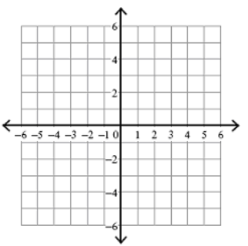
5) A(-1, 2) and B(-1, -5)

Directions 6-10: Find the slope using the slope formula.

6) (2, 3) and (5, 6) 7) (-2, -2) and (1, -2)

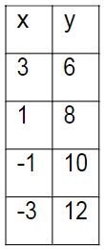
8) (2, 1) and (2, -2) 9)

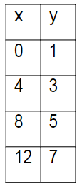
10)

