Unit 4 - Systems of Equations
Lesson 1: Solving a system of linear equations graphically.
Objective: Today we will solve a system of linear equations graphically.
Standard: 8.EE.8a
Graphically
- Identify the _______ and ______________ for the first equation.
- Graph and _______ the first equation.
- Identify the _______ and _____________ for the second equation.
- Graph and _______ the second equation.
- Write the point of intersection as an ordered pair to represent the __________.
Example:
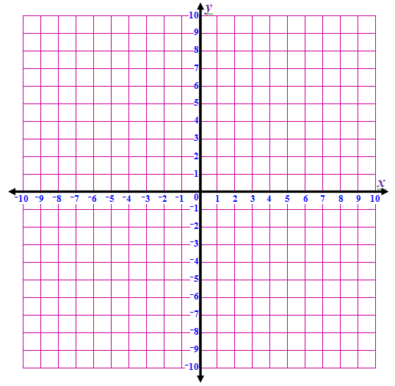
Solve the following system of equations graphically.
$y=x+2$ $y=2x+1$

Lesson 2: Solving a system of linear equations graphically when one or both equations are not given in slope-intercept form.
Objective: Today we will solve a system of linear equations graphically.
Standard: 8.EE.8a
Graphically
- Make sure both equations are in ______________________________________
- Identify the _______ and ___________________ for the first equation.
- Graph and _______ the first equation.
- Repeat for the second equation.
- Write the point of intersection as an ordered pair to represent the ___________.
Example:
Solve the following system of linear equations graphically.
$3x+4y=12$ $y=-\frac{3}{4}x+3$

Lesson 3: Solving a system of linear equations using substitution.
Objective: Today we will solve a system of linear equations algebraically.
Standard: 8.EE.8b
Substitution
- Make sure both equations are $____________$
- Since $y=y$ set both equations _______________ each other
- Solve the equation
- Solve for the other variable by substituting the known variable
- Write the answer as an _____________________
- _______ the solution in both equations
Example:
Solve the following system of linear equations algebraically.
$$y=-x+8$$
$$y=3x$$

Lesson 4: Solving a system of linear equations using substitution.
Objective: Today we will solve a system of linear equations algebraically.
Standard: 8.EE.8b
Substitution – Day 2
- Make sure both equations are $y=$
- Since $y=y$ set both equations equal to each other
- Solve the equation
- Solve for the other variable by substituting the known variable
- Write the answer as an ordered pair
- Check the solution in both equations
Example:
Solve the following system of linear equations algebraically.
$$y=-x+4$$
$$2x-2y=10$$

Lesson 5: Solving a system of linear equations using elimination.
Objective: Today we will solve a system of linear equations algebraically.
Standard: 8.EE.8b
Elimination (Addition)
The Addition Method (Elimination):
- Make sure the ___________________ are lined up.
- _____ the equations to eliminate one of the variables.
- Solve the resulting equation.
- ____________ your answer into ONE of the equations.
- Solve for the second variable.
- Write your answer as an ______________________.
- Check the solution in both equations.
Example:
Solve the following system of equations algebraically.
$5x-4y=-21$
$$-2x+4y=18$$

Lesson 6: Solving a system of linear equations using elimination.
Objective: Today we will solve a system of linear equations algebraically.
Standard: 8.EE.8b
Elimination (Multiplication)
Sometimes variables will not have opposite coefficients to eliminate nicely.
IF this happens, you will need to:
- Make sure the like variables are lined up.
- __________ each equation by the coefficient in the other equation.
**You may need to change the sign of one of the coefficients.
- _____ the equations together to eliminate a variable.
- Solve the resulting equation.
- ____________ your answer into ONE of the equations.
- Solve for the second variable.
- Write your answer as an ___________________.
- Check the solution in both equations.
Example:
Solve the system of linear equations algebraically.
$$7x+2y=5$$
$$2x+3y=16$$

Lesson 7: Understanding Types of Solutions.
Objective: Today we will identify the number of solutions for a given system of linear equations.
Standard: 8.EE.8a
Each system of equations can have one of three types of solutions:
- _________________________
- _________________________
- _________________________
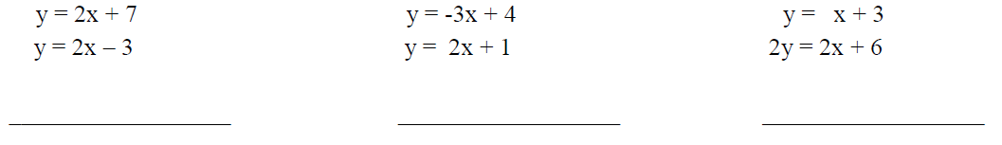

Rule:
How do you know how many solutions?
One solution: _________________________________________
No Solution: _________________________________________
Infinite Solutions: _____________________________________________

Lesson 8: Understanding Solutions to Systems of Linear Equations.
Objective: Today we will explain solutions to systems of linear equations.
Standard: 8.EE.8a
How can we determine if a given point is a solution to a system of linear equations?
__________________________________________________________________
Is the point $(4, 3)$ a solution to the lines $x+y=7$ and $x-y=1$? Justify your answer.

What do you think the graph of the above lines looks like? ________________________
___________________________________________________________________

Lesson 9: Word Problems.
Objective: Today we will solve real-life word problems involving systems of linear equations.
Standard: 8.EE.8c
- Write a _____ statement to define what $x$ and $y$ stand for
- Write two equations to represent the situation
- Solve for one variable
- Solve for the other variable by substituting the known variable
- Write the answer
- Check your solution
Examples:
- The sum of two numbers is 18. Two times the larger plus three times the smaller equals 27. Find the numbers.

- A warehouse stacks 3 large boxes and two small boxes to a height of 11 feet. It also stacks two large boxes and 1 small box to a height of 7 feet. What are the heights of the large and small box?

