Unit 6 - Transformations
Lesson 1: Review Graphing
Objective: Today we will review graphing points.
The Quadrants
A coordinate plane is broken up into four sections called _______________.
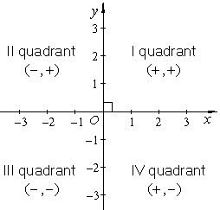
Plot the following points and identify the quadrant in which they lie:
$A(2, -6)$ $B(-7, -3)$ $C(-5, 5)$
$D(-4, -1)$ $E(1, -1)$ $F(6, 4)$
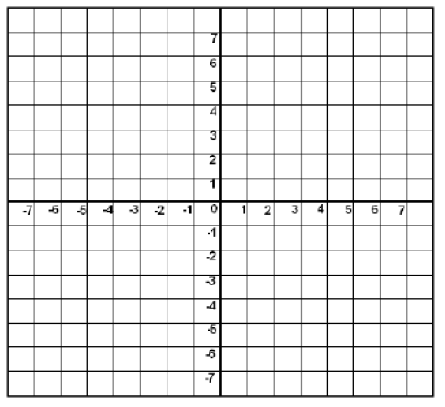
Write the coordinate points from the given graph:
$A(___,___)$ $B(___,___)$ $C(___,___)$ $D(___,___)$ $E(___,___)$ $F(___,___)$
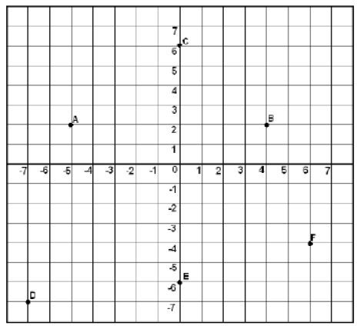
Plot the following points and identify the geometric shapes formed by joining the points:
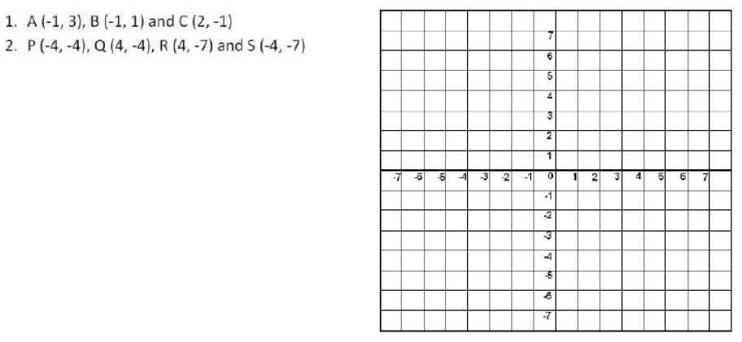

Lesson 2: Reflections
Objective: Today we will draw the reflection of a figure over a given axis.
Standard: 8.G. 1, 8.G.3
A ____________ is a mirror image of the original figure. Each point of the preimage and its image are the same distance from the line of reflection.
Reflections create __________ figures.
You can reflect figures over the _______ and over the ________.
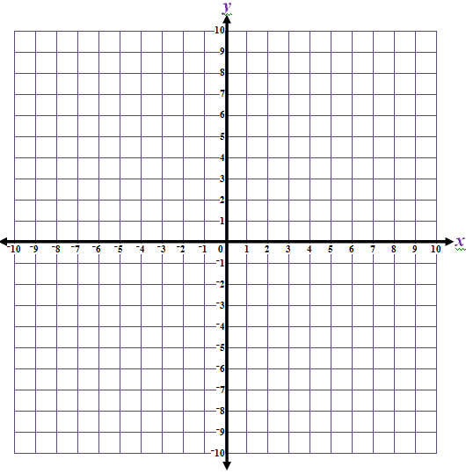
To reflect a figure over the x-axis:
Change the sign of the __________.
M
Triangle MAD is plotted on the grid.
Draw the image of MAD
reflected in the x-axis.
A
D
M (3, 6) M’ (___ , ___)
A (8, 1) A’ (___ , ___)
D (___ , ___) D’ (___ , ___)

To reflect a figure over the y-axis:
Change the sign of the _________.
Trapezoid DOGS is plotted on the grid.
Draw the image of DOGS
reflected in the y-axis.
D (-6 , -2) D’ (___ , ___)
S
GZZZZ
OZZ
D
O (-2 , -5) O’ (___ , ___)
G (___ , ___) G’ (___ , ___)
S (___ , ___) S’ (___ , ___)
Lesson 3: Dilations
Objective: Today we will complete dilations of figures on a coordinate grid.
Standard: 8.G. 1, 8.G.3
A _________ uses a ________________, k, to enlarge or reduce a figure.
- If $k>1$ the image will be an enlargement of the original figure.
- If $0<k<1$ the image will be a reduction of the original figure.
- If $k=1$ the image will be the same as the original figure.

To dilate a figure by a given scale factor, __________ the coordinates by the scale factor.
Dilations create an image that is _________ to the original figure. The image is the same shape but not necessarily the same size.

Parallelogram FBI has the coordinates:
F = (–2, 3) | B = (3, –1) | I = (–3, –3)
Draw & Label a Dilation of 3: (x, y) → (3x, 3y)
Fʹ = ______ | Bʹ = ______ | Iʹ = ______
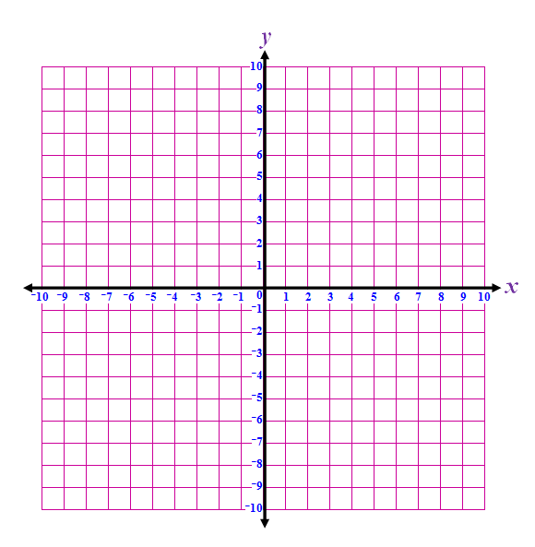
Draw & Label this image F’B’I’.
BN
I
F

Lesson 4: Translations
Objective: Today we will translate figures on a coordinate grid.
Standard: 8.G. 1, 8.G.3
A __________ slides a figure from one position to another position without turning it.
Translations create ________ figures.
Triangle BAD has coordinates:
B = (–7, 9) | A = (–2, 5) | D = (–9, 2)
Draw & Label the image of B’A’D’ under the transformation:
(x, y) → (x + 7, y – 5)
B’ = ________ | A’ = ________ | D’ = ________
D
A
B

Lesson 3: Rotations
Objective: Today we will rotate figures around the origin.
Standard: 8.G. 1, 8.G.3
A _________ is a transformation in which a figure is rotated, or turned, about a fixed point. The fixed point is called the center of rotation.
Rotations create _________ figures. Each point and its image are the same distance from the center of rotation.

Rules for Rotations
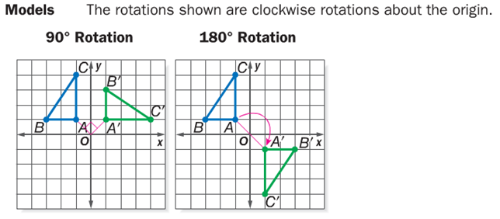
Symbols
$\left(x, y\right)→\left(_________\right)$ $\left(x, y\right)→\left(___________\right)$
Switch x- and y- values Change the sign of
Change the sign of $x$ both x- and y-values
$(3, 4)→$ $(-2, 1)→$

Draw and Label the figure under a $90°$ clockwise rotation.
Parallelogram NOSE | 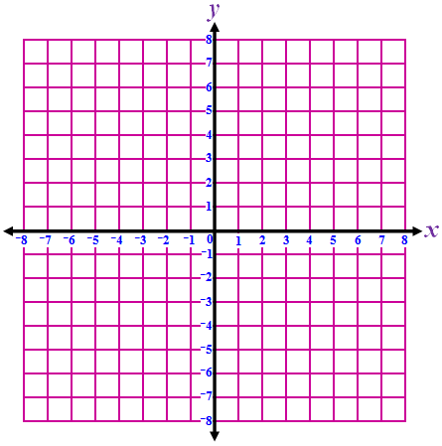  Image NʹOʹSʹEʹ  (x, y) → (y, –x)
N = (–6, –5) | Nʹ = ________
O = (–4, –5) | Oʹ = ________
S = (–4, –2) | Sʹ = ________
E = (–6, –2) | Eʹ = ________  O  S  E  N

Draw the Rotation of Rectangle I 180º clockwise about the origin.
Label Point I as: I’ on the rotated figure.
Find the Coordinates of: I’_______
I

Lesson 5: Sequences of Transformations
Objective: Today we will identify the sequence of transformations.
Standard: 8.G. 1, 8.G.3
If you have two congruent figures, you can determine the transformation, or ______ of transformations, that maps one figure onto the other by analyzing the ____________ or relative __________ of the figures.
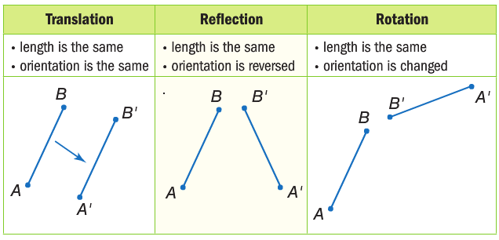
Identify a sequence of transformations that will transform figureinto figure
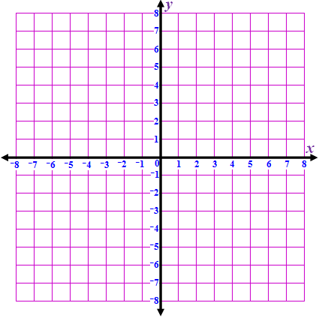
T
R
E
A
H
S
Hʹ
Aʹ
Eʹ
Rʹ
Tʹ
A. Reflection (over x-axis) & Translation (right & up)
B. Rotation (90° clockwise) & Reflection (over x-axis)
C. Rotation (90° counterclockwise) & Reflection (over y-axis)
Sʹ
D. Rotation (90° counterclockwise) & Translation (up & right)

